**DIAGRAMS OF ONLINE SHOPPING SYSTEM:**

**USE CASE DIAGRAM:**

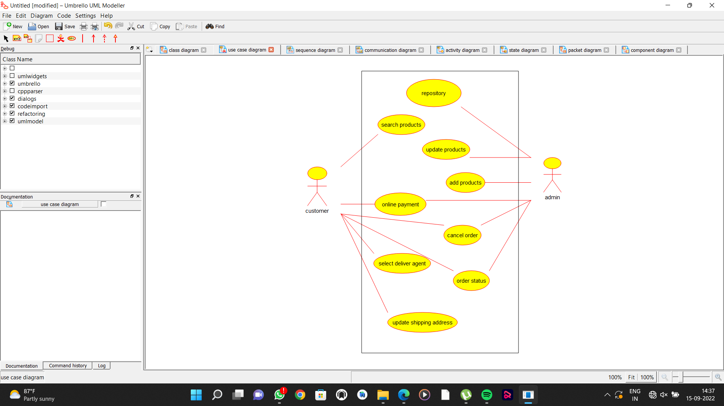

**COLLABORATION DIAGRAM**

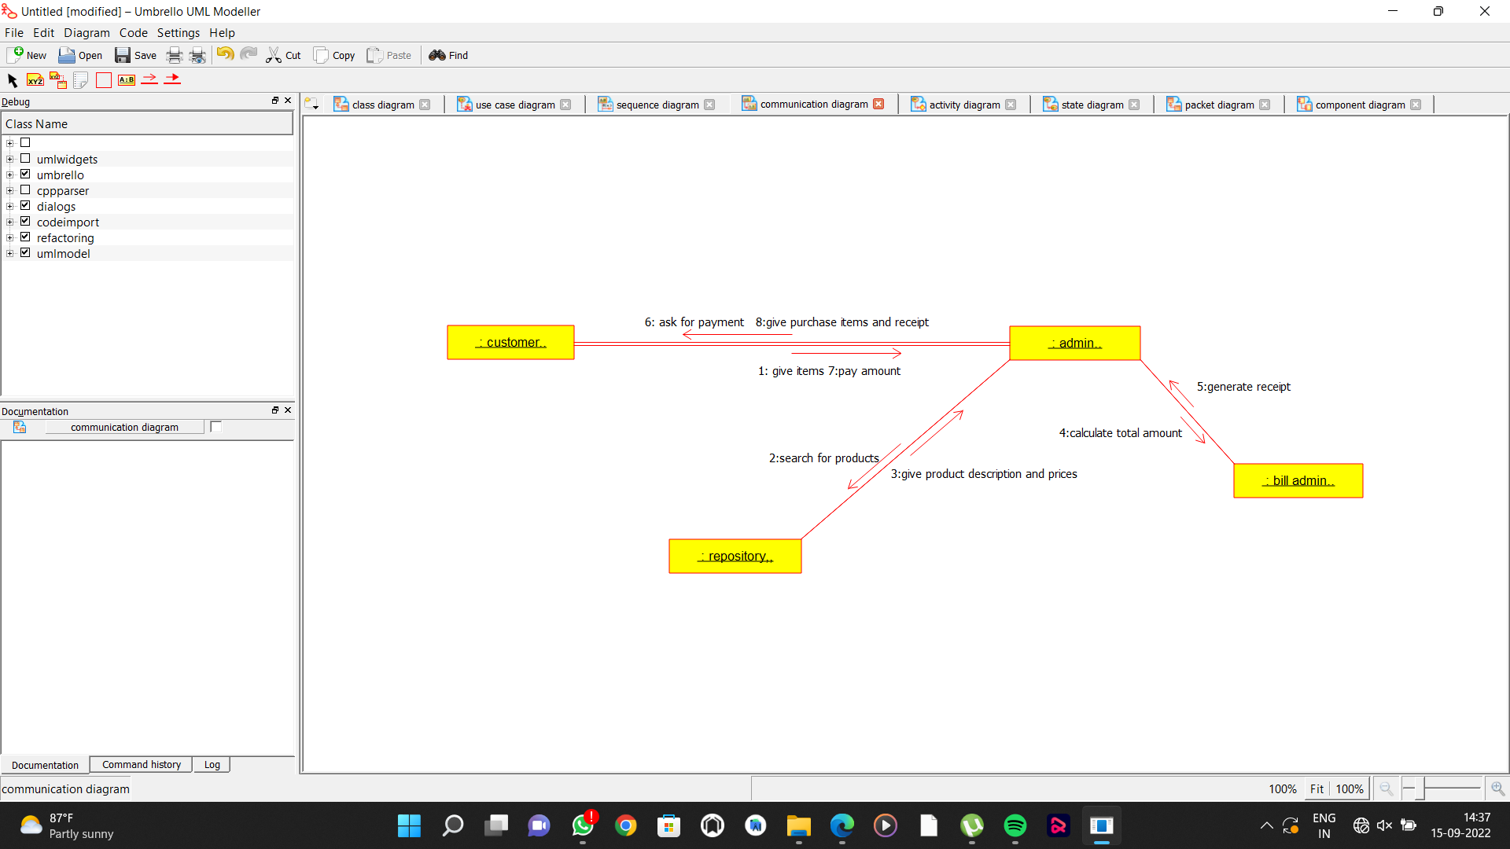

**ACTIVITY DIAGRAM:**

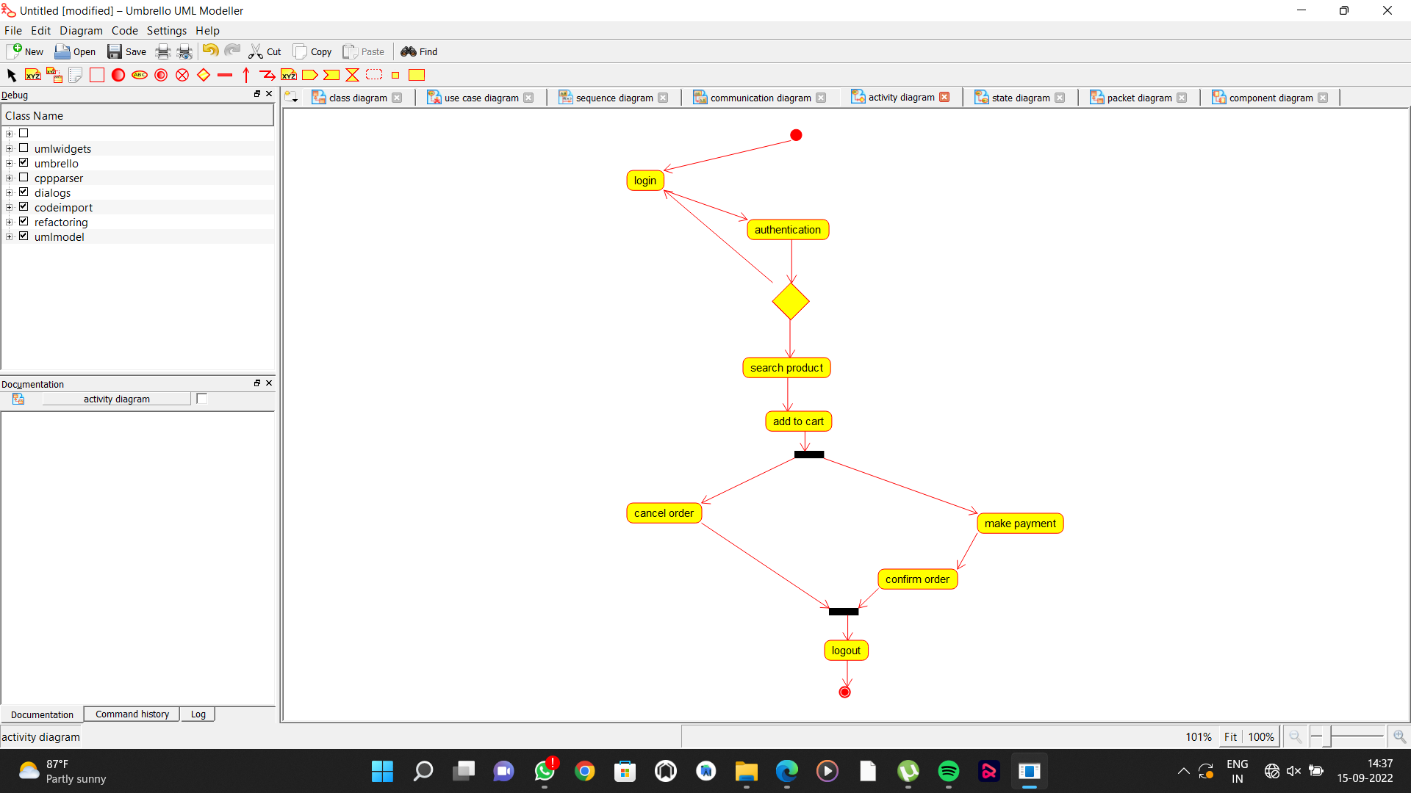

**SEQUENCE DIAGRAM:**

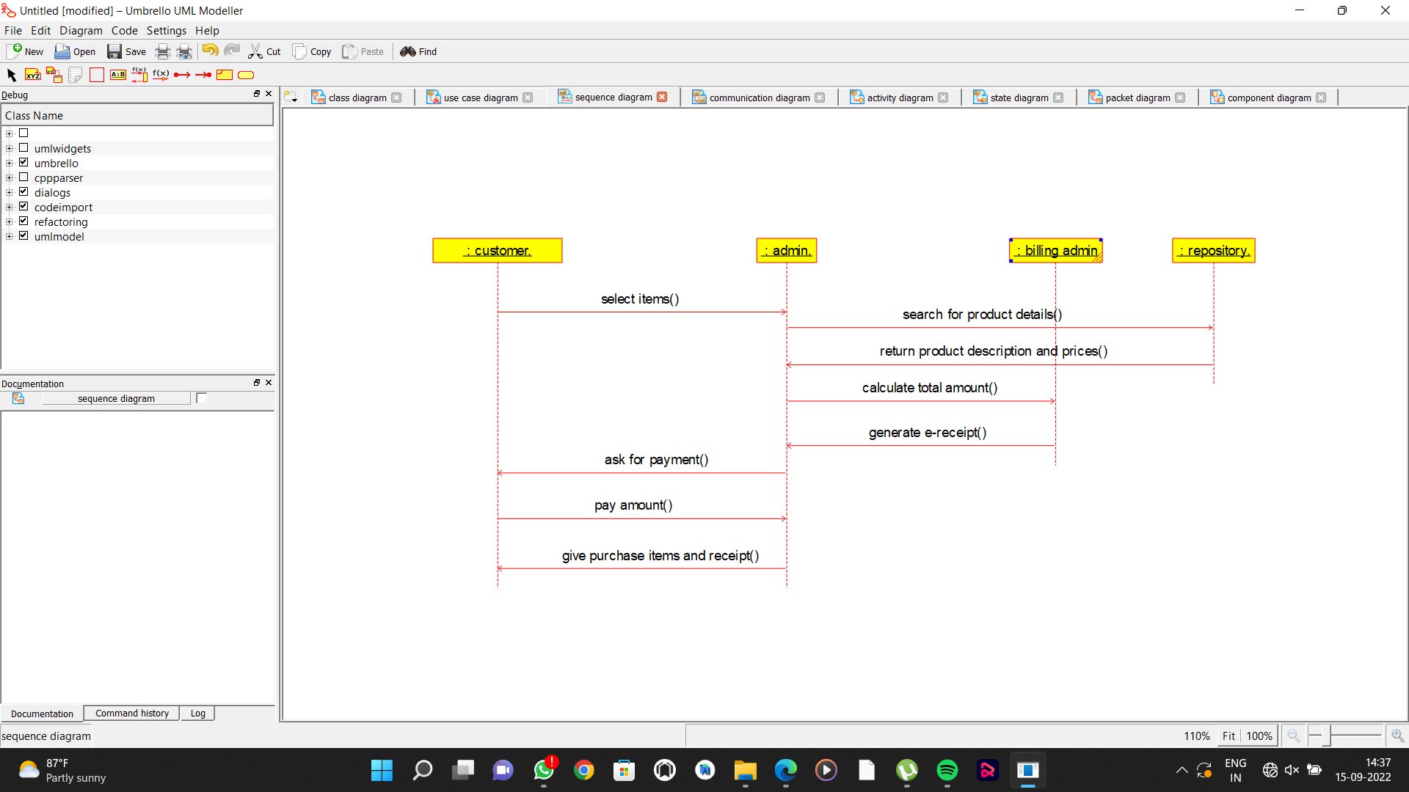

**CLASS DIAGRAM:**

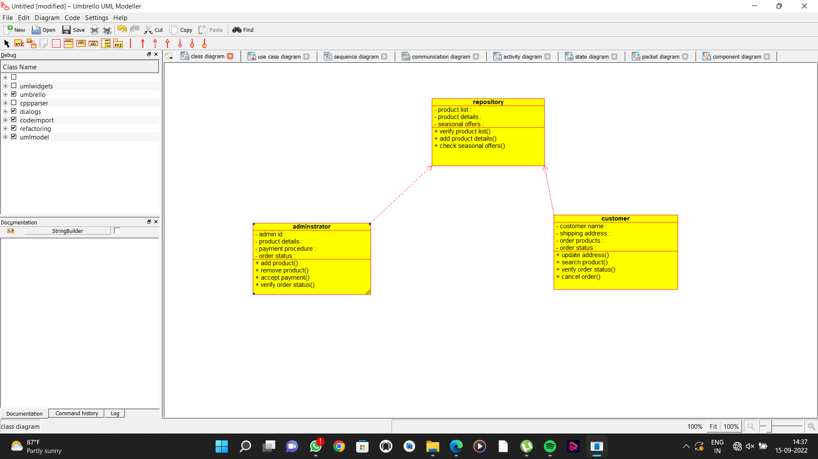

**COMPONENT DIAGRAM:**

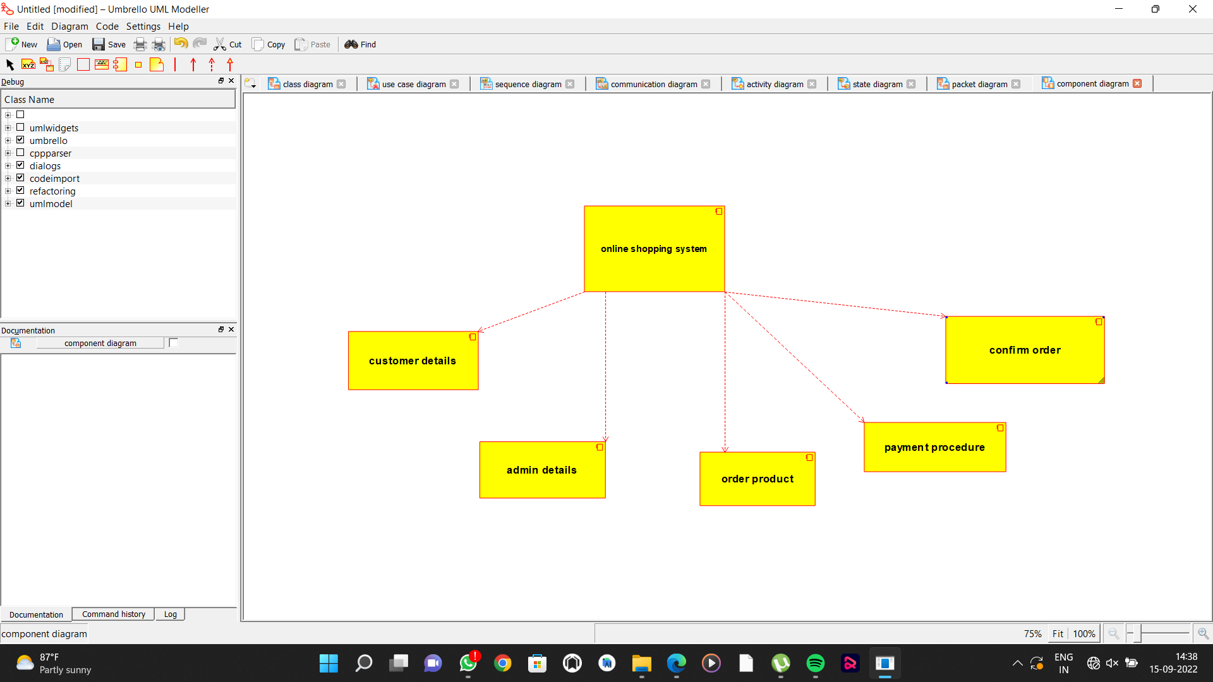

**STATE CHART DIAGRAM:**

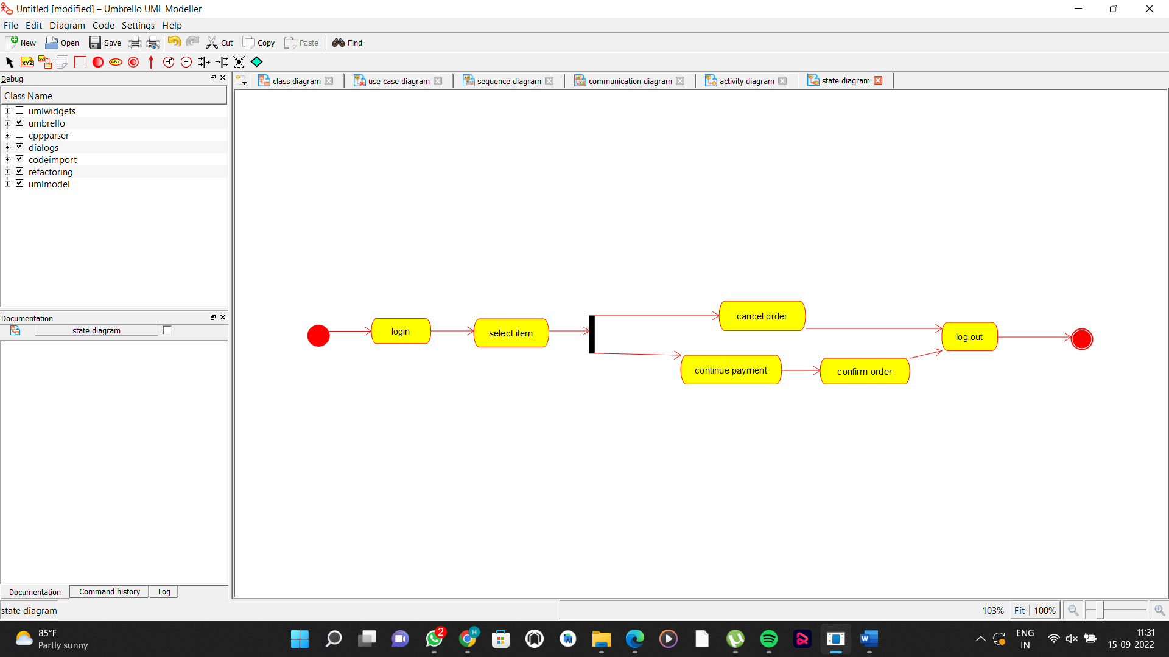

**PACKAGE DIAGRAM:**

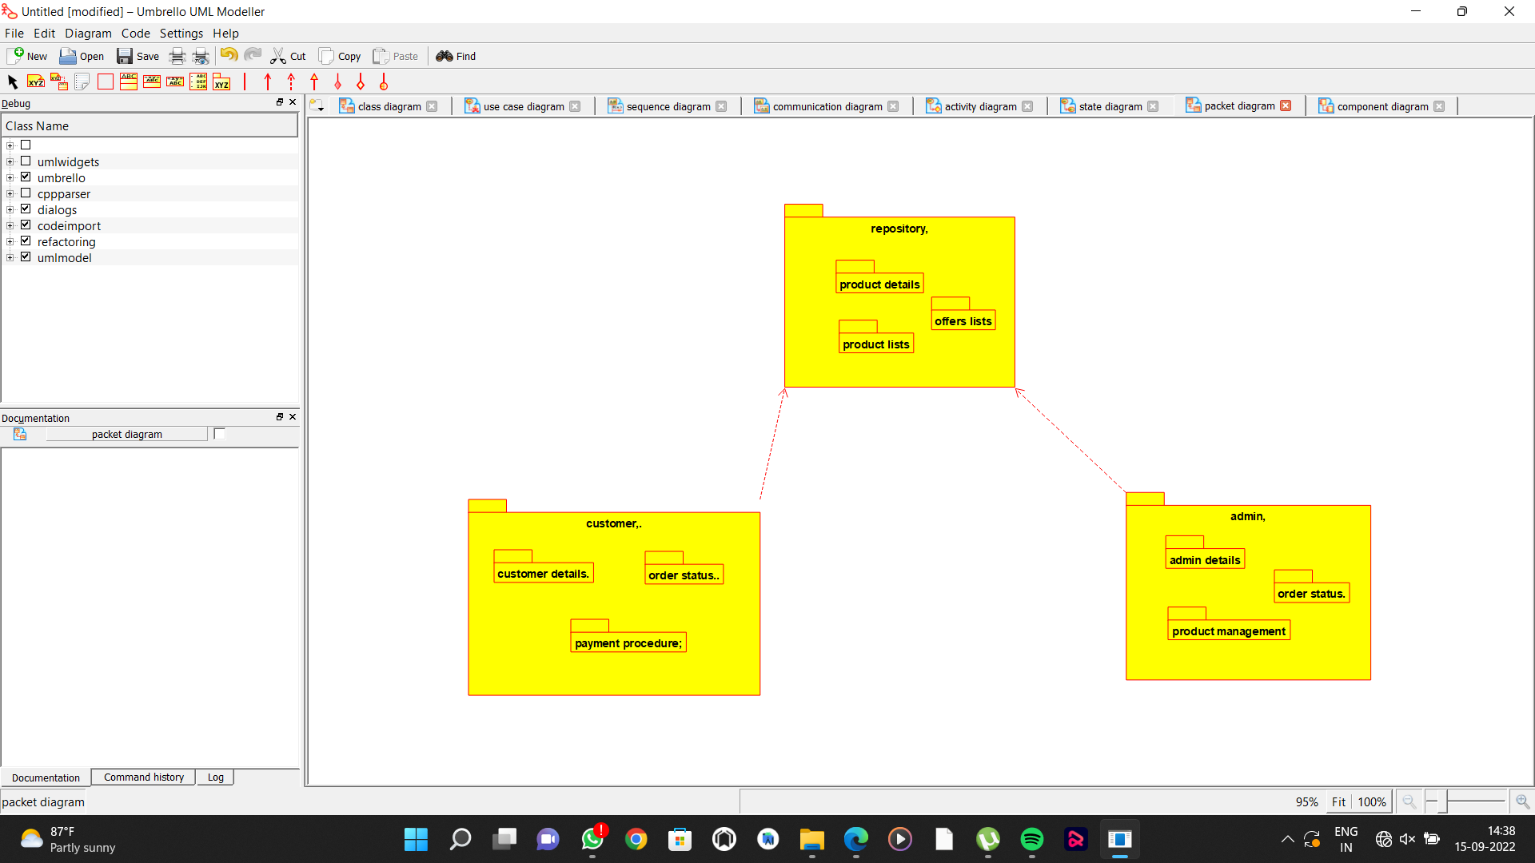

**DEPLOYMENT DIAGRAM:**

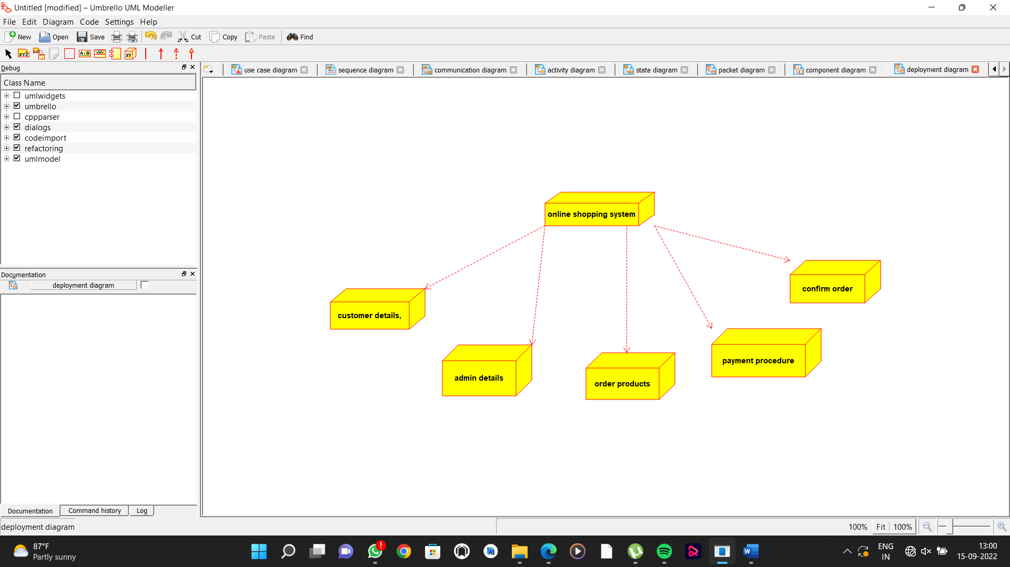

**PROGRAMS:**

